**Real Case Scenario #4**

A follow-up is needed for a user who contacted us yesterday. Due to time constraints, he decided to continue the process later. He has now reached out again to resume troubleshooting. The user did not provide any additional information but mentioned that his printer is still not connecting to the Wi-Fi, as was the issue yesterday. Please include all the steps taken through the ticketing system and the entire process carried out.

**User’s information:**

Name: Dennis L.  
Account ID: 95745897  
Phone Number: +12257896451  
Email: dennis4@outlook.com

**Tools**  
Ticketing System: [Sign in to Zendesk](https://www.zendesk.com/login/)  
HP Website: [Service status](https://support.hp.com/us-en/check-warranty)

**Possible Causes:**

* Incorrect Wi-Fi settings.
* Weak Wi-Fi signal.
* Network issues.

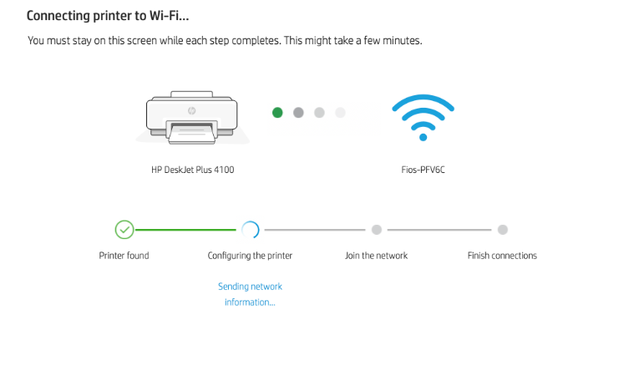

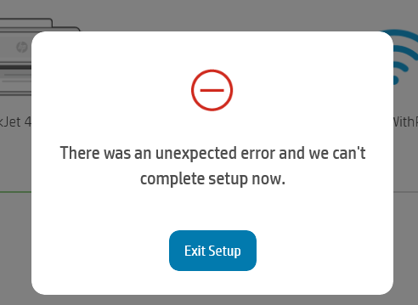

**Troubleshooting Steps**

1. **Check Wi-Fi Settings:**
   * Ensure the printer is connected to the correct Wi-Fi network.
   * Enter the correct Wi-Fi password if prompted.
2. **Move Printer Closer to Router:**
   * Ensure the printer is within range of the Wi-Fi router.
   * Avoid placing the printer near large metal objects or other devices that may interfere with the signal.
3. **Restart Printer and Router:**
   * Turn off the printer and unplug the router.
   * Wait for a few minutes, then plug in the router and turn on the printer.
4. **Update Printer Firmware:**
   * Go to the printer manufacturer’s website and download the latest firmware for your printer model.
   * Follow the instructions to update the firmware.
5. **Check Network Settings:**
   * Ensure the printer’s network settings are configured correctly.
   * Refer to the printer’s manual for instructions on accessing and configuring network settings.